### 4th March 2016

### New App launched by YOKOHAMA Europe at Geneva

YOKOHAMA, the Japanese Tyre manufacturing company which was established in 1917 evolves with the times and places a significant focus on innovation, safe tyres and products which are beneficial to society.

Currently exhibiting at the prestigious Geneva International Motor Show where it has launched its new products, the European Head Office has also taken the opportunity to present the YOKOHAMA Europe App which uses dynamic content and advanced augmented reality to showcase its technology, products and areas of global interest to users.

According to David Oliva, Communications Manager for YOKOHAMA Europe, “The App will offer users, a unique opportunity to access exclusive content with easy steps. News about YOKOHAMA, our football partnership, Motorsport involvement, or illustrating the significant environmental projects the company is committed to. There is also a tyre finder for those seeking new quality tyres, and via a scan function which can be used on YOKOHAMA catalogues and materials, provide images, graphics, documentation and videos showing some of the main focuses of YOKOHAMA activity.”

“As a special incentive to those downloading the app in Europe, they will also be able to take part in a competition to win some exclusive experiences and items with the YOKOHAMA Europe App”. Concluded Oliva.

The App is available free of charge on the App Store and on Google Play.

For more information: [www.yokohama-online.com/app](http://www.yokohama-online.com/app)

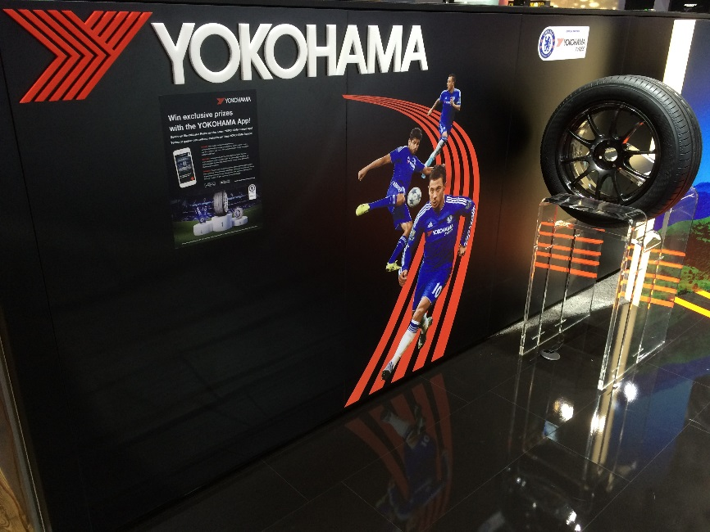

*New App launched by YOKOHAMA Europe at Geneva*